Student Management

Use-Case Specification: Create Instructor

Version <1.0>

Revision History

|  |  |  |  |
| --- | --- | --- | --- |
| **Date** | **Version** | **Description** | **Author** |
| <dd/mmm/yy> | <x.x> | Final version | Đào Anh Thành |
|  |  |  |  |
|  |  |  |  |
|  |  |  |  |

Table of Contents

1. Create new instructor 3

1.1 Brief Description 3

2. Flow of Events 3

2.1 Basic Flow 3

2.2 Alternative Flows 3

2.2.1 < First Alternative Flow > 3

2.2.2 < Second Alternative Flow > 3

3. Special Requirements 3

3.1 < First Special Requirement > 3

4. Preconditions 3

4.1 < Precondition One > 3

5. Postconditions 3

5.1 < Postcondition One > 3

6. Extension Points 3

6.1 <Name of Extension Point> 3

Use-Case Specification: Creating new instructor

# Create new instructor

## Brief Description

This use case defines the steps of adding a new instructor to store it in the database system. Administrator can easily add a new instructor in the database.

## Actor

Administrator

# Flow of Events

## Basic Flow

The system administrator selects to add a new instructor and enters all information of this instructor to store in the database system. The administrator sets the database management parameter that holds instructor information that has just added. The system displays the new instructor’s data value and logs the change.

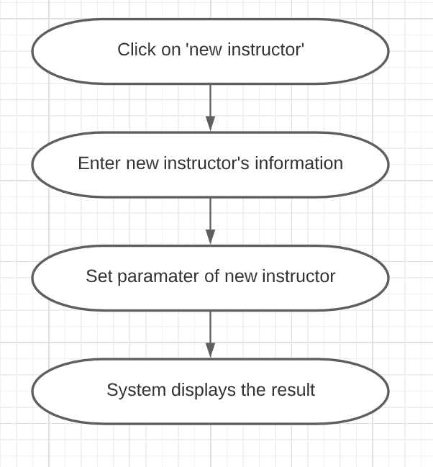

# Special Requirements

Administrator has basic knowledge of manipulating the database.

# Preconditions

The added instructor had not existed in the database before.

# Postconditions

Administrator checks the database and the website to ensure that the new instructor is added successfully.

# Extension Points

No extension points.